**Assignment3**

**201133216 정유석**

**ScreenShot**

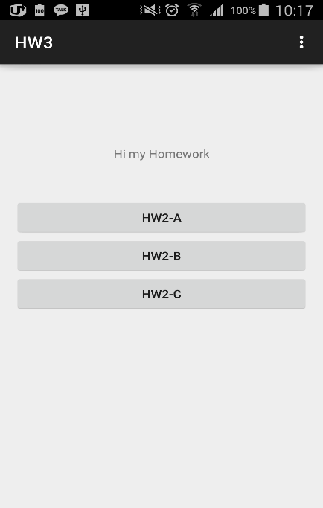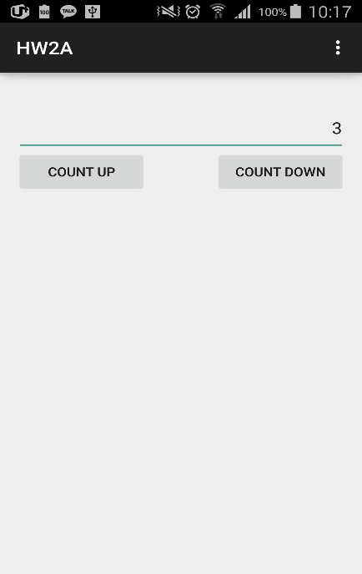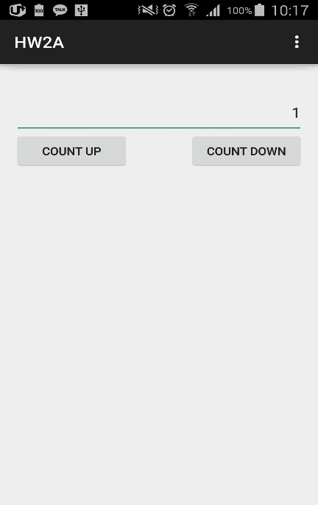

<First> <Click HW2-A button and count up 3 click> <Click count down 2>

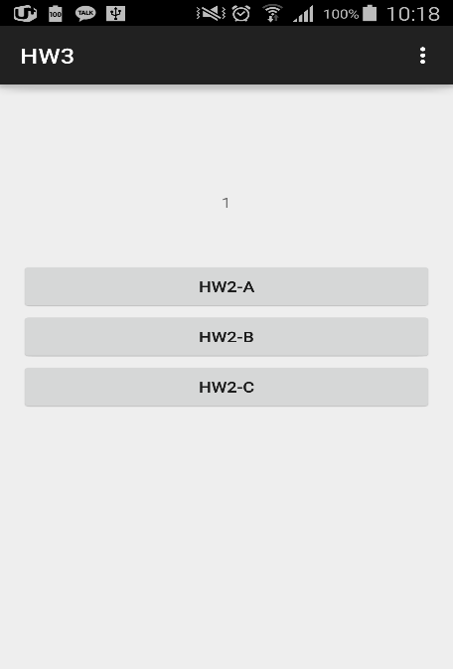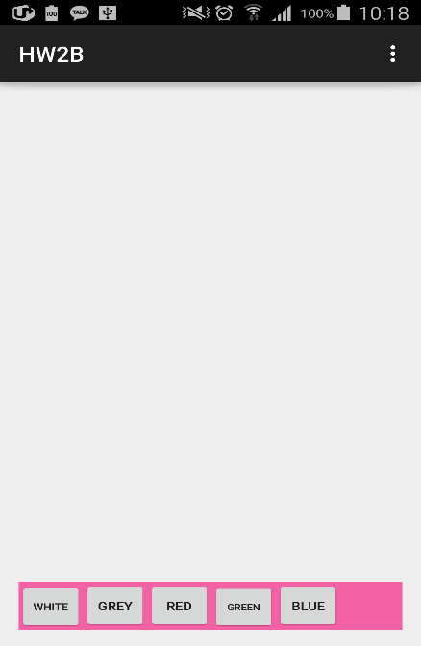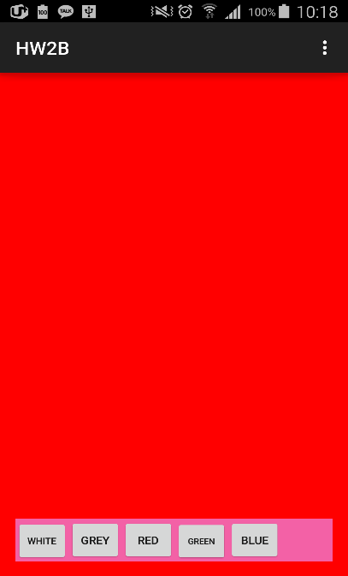

<Cancle> <Click HW2-B button> <Click Red button>

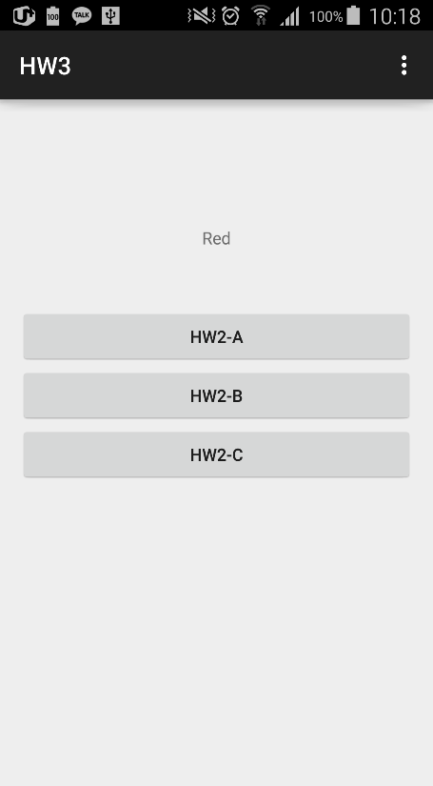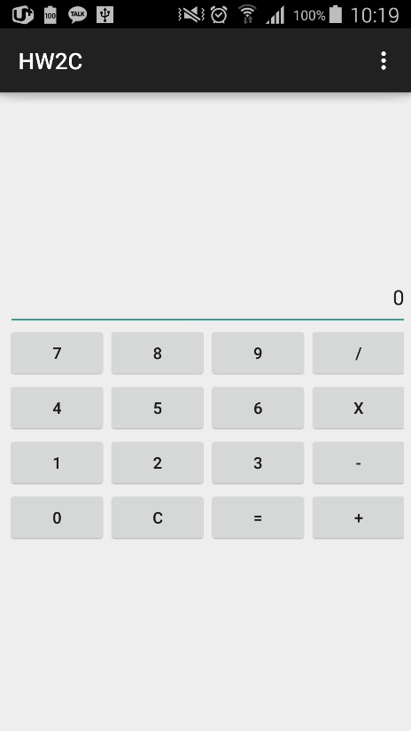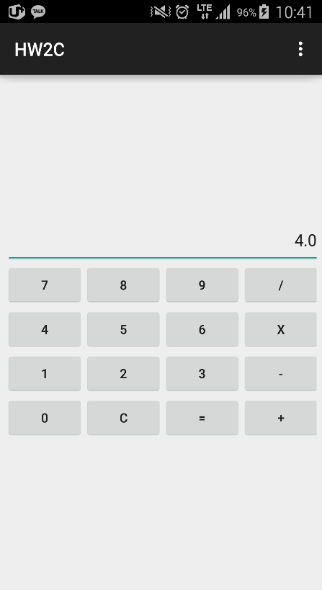 <Cancle> <Click HW2-C> <Click 4>

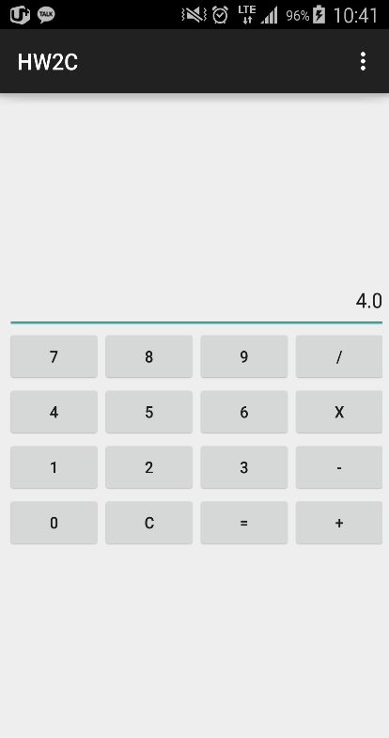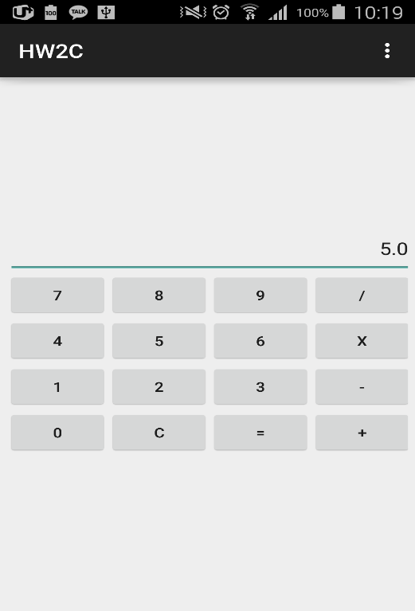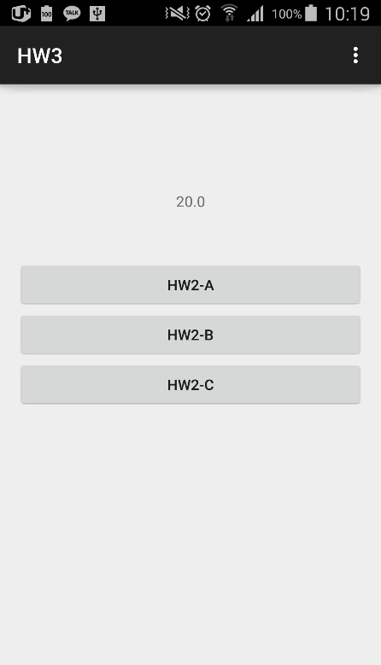

<X> <Click 5> < Click = >

**Code**

**MainActivity**

package com.example.hw3;

import android.support.v7.app.ActionBarActivity;

import android.app.Activity;

import android.content.Intent;

import android.os.Bundle;

import android.view.Menu;

import android.view.MenuItem;

import android.view.View;

import android.widget.TextView;

public class MainActivity extends ActionBarActivity {

TextView Post; //It is used to post the result

@Override

protected void onCreate(Bundle savedInstanceState) {

super.onCreate(savedInstanceState);

setContentView(R.layout.activity_main);

Post = (TextView)findViewById(R.id.textView1);

}

public void click2A(View v){ //Click Listener for A Hw2-A button

Intent HW1 = new Intent(MainActivity.this, HW2A.class); //Create Intent to HW2A Class

startActivityForResult(HW1,0); //Pass Intent to HW2A

}

public void click2B(View v){//Click Listener for A Hw2-B button

Intent HW2 = new Intent(MainActivity.this, HW2B.class);//Create Intent to HW2B Class

startActivityForResult(HW2,1);

}

public void click2C(View v){//Click Listener for A Hw2-C button

Intent HW3 = new Intent(MainActivity.this, HW2C.class);//Create Intent to HW2C Class

startActivityForResult(HW3,2);

}

@Override

protected void onActivityResult(int requestCode, int resultCode, Intent data) { //receipt intent from other activity

super.onActivityResult(requestCode, resultCode, data);

try { //Check requestCode (= check Activity)

if ((requestCode == 0 ) && (resultCode == Activity.RESULT_OK)){

//If requestCode = 0 --> HW2A class

int temp = data.getIntExtra("hw1",0);

//Set Text

Post.setText(Integer.toString(temp));

}

if ((requestCode == 1 ) && (resultCode == Activity.RESULT_OK)){

//If requestCode = 0 --> HW2A class

String temp2 = data.getStringExtra("hw2");

//Set Text

Post.setText(temp2);

}

if ((requestCode == 2 ) && (resultCode == Activity.RESULT_OK)){

//If requestCode = 0 --> HW2A class

float temp1 = data.getFloatExtra("hw3", 0);

//Set Text

Post.setText(Float.toString(temp1));

}

}

catch (Exception e) {//Error code

Post.setText("Problems ‐ HW2- "+ resultCode);

}

}//onActivityResult

@Override

public boolean onCreateOptionsMenu(Menu menu) {

// Inflate the menu; this adds items to the action bar if it is present.

getMenuInflater().inflate(R.menu.main, menu);

return true;

}

@Override

public boolean onOptionsItemSelected(MenuItem item) {

// Handle action bar item clicks here. The action bar will

// automatically handle clicks on the Home/Up button, so long

// as you specify a parent activity in AndroidManifest.xml.

int id = item.getItemId();

if (id == R.id.action_settings) {

return true;

}

return super.onOptionsItemSelected(item);

}

}

**HW2A**

package com.example.hw3;

import android.support.v7.app.ActionBarActivity;

import android.app.Activity;

import android.content.Intent;

import android.os.Bundle;

import android.view.Menu;

import android.view.MenuItem;

import android.view.View;

import android.view.View.OnClickListener;

import android.widget.Button;

import android.widget.EditText;

import android.widget.Toast;

public class HW2A extends ActionBarActivity implements OnClickListener {

Button button_UP,button_Down; //They are used to connect activity

EditText text; //It is used to connect activity

Intent myLocalIntent ; //Create Intent

@Override

protected void onCreate(Bundle savedInstanceState) {

super.onCreate(savedInstanceState);

setContentView(R.layout.hw1);

text = (EditText)findViewById(R.id.textView1); //Connect to activity using R class

button_UP = (Button)findViewById(R.id.B_UP); //Connect to activity using R class

button_Down = (Button)findViewById(R.id.B_DOWN); //Connect to activity using R class

button_UP.setOnClickListener(this); //Make event listener

button_Down.setOnClickListener(this);

}

@Override

public void onClick(View v) {

myLocalIntent = getIntent();

//Count up button

String temp = text.getText().toString(); //Receive the text string

int tmp = Integer.parseInt(temp); //Convert to integer

if(v.getId() ==button_UP.getId())

tmp++; //Count up

//Count down button

if(v.getId() ==button_Down.getId())

tmp--; //Count down

text.setText(Integer.toString(tmp)); //Set count to text

myLocalIntent.putExtra("hw1", tmp); //Set Intent

setResult(Activity.RESULT_OK, myLocalIntent); //Pass intent to MainActivity

}

@Override

public boolean onCreateOptionsMenu(Menu menu) {

// Inflate the menu; this adds items to the action bar if it is present.

getMenuInflater().inflate(R.menu.main, menu);

return true;

}

@Override

public boolean onOptionsItemSelected(MenuItem item) {

// Handle action bar item clicks here. The action bar will

// automatically handle clicks on the Home/Up button, so long

// as you specify a parent activity in AndroidManifest.xml.

int id = item.getItemId();

if (id == R.id.action_settings) {

return true;

}

return super.onOptionsItemSelected(item);

}

}

**HW2B**

package com.example.hw3;

import android.support.v7.app.ActionBarActivity;

import android.app.Activity;

import android.content.Intent;

import android.graphics.Color;

import android.os.Bundle;

import android.view.Menu;

import android.view.MenuItem;

import android.view.View;

import android.view.View.OnClickListener;

import android.widget.Button;

import android.widget.RelativeLayout;

import android.widget.Toast;

public class HW2B extends ActionBarActivity implements OnClickListener {

Button B1,B2,B3,B4,B5; //Make buttons (Using connect to activity)

RelativeLayout RL; //Make Layout (Using connect to activity)

Intent returnIntent; //Create intent

@Override

protected void onCreate(Bundle savedInstanceState) {

super.onCreate(savedInstanceState);

setContentView(R.layout.hw2);

//Connect to activity using R class

RL = (RelativeLayout)findViewById(R.id.RTL);

B1 = (Button)findViewById(R.id.White);

B2 = (Button)findViewById(R.id.Grey);

B3 = (Button)findViewById(R.id.Red);

B4 = (Button)findViewById(R.id.Green);

B5 = (Button)findViewById(R.id.Blue);

//Make event listener

B1.setOnClickListener(this);

B2.setOnClickListener(this);

B3.setOnClickListener(this);

B4.setOnClickListener(this);

B5.setOnClickListener(this);

}

@Override

public void onClick(View v){

String color ="";

returnIntent = getIntent();

//Click the white button, change the layout background to white

if(v.getId() == B1.getId()) {

RL.setBackgroundColor(Color.rgb(255, 255, 255));;

color = "White";

}

//Click the grey button, change the layout background to grey

if(v.getId() == B2.getId()){

RL.setBackgroundColor(Color.rgb(140, 140, 140));;

color = "Grey";

}

//Click the red button, change the layout background to red

if(v.getId() == B3.getId()){

RL.setBackgroundColor(Color.rgb(255, 0, 0));;

color = "Red";

}

//Click the green button, change the layout background to green

if(v.getId() == B4.getId()){

RL.setBackgroundColor(Color.rgb(0, 255, 0));;

color = "Green";

}

//Click the blue button, change the layout background to blue

if(v.getId() == B5.getId()){

RL.setBackgroundColor(Color.rgb(0, 0, 255));;

color = "Blue";

}

returnIntent.putExtra("hw2", color); //Set intent

setResult(Activity.RESULT_OK, returnIntent); //Pass intent to MainActivity

}

@Override

public boolean onCreateOptionsMenu(Menu menu) {

// Inflate the menu; this adds items to the action bar if it is present.

getMenuInflater().inflate(R.menu.main, menu);

return true;

}

@Override

public boolean onOptionsItemSelected(MenuItem item) {

// Handle action bar item clicks here. The action bar will

// automatically handle clicks on the Home/Up button, so long

// as you specify a parent activity in AndroidManifest.xml.

int id = item.getItemId();

if (id == R.id.action_settings) {

return true;

}

return super.onOptionsItemSelected(item);

}

}

**HW2C**

package com.example.hw3;

import android.support.v7.app.ActionBarActivity;

import android.app.Activity;

import android.content.Intent;

import android.os.Bundle;

import android.view.Menu;

import android.view.MenuItem;

import android.view.View;

import android.view.View.OnClickListener;

import android.widget.Button;

import android.widget.EditText;

import android.widget.Toast;

public class HW2C extends ActionBarActivity implements OnClickListener{

Button B0,B1,B2,B3,B4,B5,B6,B7,B8,B9,BM,BP,BD,BS,BC,BE; //Make buttons (Using connect to activity)

EditText Edit; //Make Edit (Using connect to activity)

float sum = 0; //It is used to summary in calculator

float temp = 0; //It is next operation ( ex) 5 % 5(this))

int code = 0; //code=1 -> + , code=2 -> - , code=3 -> / , code=4 -> X

int check = 0; //It is used to next calculation ( ex) 5 -> X -> 5 -> X (this) )

Intent returnIntent; //Create intent

@Override

protected void onCreate(Bundle savedInstanceState) {

super.onCreate(savedInstanceState);

setContentView(R.layout.hw3);

//It connect java and activity using R class

Edit = (EditText)findViewById(R.id.edit);

B0 = (Button)findViewById(R.id.Bzero);

B1 = (Button)findViewById(R.id.Bone);

B2 = (Button)findViewById(R.id.Btwo);

B3 = (Button)findViewById(R.id.Bthree);

B4 = (Button)findViewById(R.id.Bfour);

B5 = (Button)findViewById(R.id.Bfive);

B6 = (Button)findViewById(R.id.Bsix);

B7 = (Button)findViewById(R.id.Bseven);

B8 = (Button)findViewById(R.id.Beight);

B9 = (Button)findViewById(R.id.Bnine);

BD= (Button)findViewById(R.id.Bdevide);

BM = (Button)findViewById(R.id.Bmultiple);

BP = (Button)findViewById(R.id.Bplus);

BC = (Button)findViewById(R.id.BC);

BE = (Button)findViewById(R.id.Bend);

BS = (Button)findViewById(R.id.Bsubtract);

//It makes event listener

B0.setOnClickListener(this);

B1.setOnClickListener(this);

B2.setOnClickListener(this);

B3.setOnClickListener(this);

B4.setOnClickListener(this);

B5.setOnClickListener(this);

B6.setOnClickListener(this);

B7.setOnClickListener(this);

B8.setOnClickListener(this);

B9.setOnClickListener(this);

BD.setOnClickListener(this);

BM.setOnClickListener(this);

BP.setOnClickListener(this);

BC.setOnClickListener(this);

BE.setOnClickListener(this);

BS.setOnClickListener(this);

}

public void onClick(View v){

if(v.getId() == B0.getId()){

//Code = 0 means It is first calculation ( ex -- 5(this) X 5 )

if(code == 0){

if(sum == 0) //It means 0 is first number

sum = 0;

else //It means 0 is none first number

sum = sum * 10;

Edit.setText(Float.toString(sum));

}

else{ //Code != 0 means It is next calculation ( ex -- 5 X 5(this) )

if(temp == 0) //It means 0 is first temp number

temp = 0;

else //It means 0 is none first temp number

temp = temp * 10;

Edit.setText(Float.toString(temp));

}

}

//It is same above B0 sentence

if(v.getId() == B1.getId()){

if(code == 0){

if(sum == 0)

sum = 1;

else{

sum = sum * 10;

sum = sum + 1;

}

Edit.setText(Float.toString(sum));

}

else{

if(temp == 0)

temp = 1;

else{

temp = temp * 10;

temp = temp + 1;

}

Edit.setText(Float.toString(temp));

}

}

//It is same above B0 sentence

if(v.getId() == B2.getId()){

if(code == 0){

if(sum == 0)

sum = 2;

else{

sum = sum * 10;

sum = sum + 2;

}

Edit.setText(Float.toString(sum));

}

else{

if(temp == 0)

temp = 2;

else{

temp = temp * 10;

temp = temp + 2;

}

Edit.setText(Float.toString(temp));

}

}

//It is same above B0 sentence

if(v.getId() == B3.getId()){

if(code == 0){

if(sum == 0)

sum = 3;

else{

sum = sum * 10;

sum = sum + 3;

}

Edit.setText(Float.toString(sum));

}

else{

if(temp == 0)

temp = 3;

else{

temp = temp * 10;

temp = temp + 3;

}

Edit.setText(Float.toString(temp));

}

}

//It is same above B0 sentence

if(v.getId() == B4.getId()){

if(code == 0){

if(sum == 0)

sum = 4;

else{

sum = sum * 10;

sum = sum + 4;

}

Edit.setText(Float.toString(sum));

}

else if (code > 0){

if(temp == 0)

temp = 4;

else{

temp = temp * 10;

temp = temp + 4;

}

Edit.setText(Float.toString(temp));

}

}

//It is same above B0 sentence

if(v.getId() == B5.getId()){

if(code == 0){

if(sum == 0)

sum = 5;

else{

sum = sum * 10;

sum = sum + 5;

}

Edit.setText(Float.toString(sum));

}

else{

if(temp == 0)

temp = 5;

else{

temp = temp * 10;

temp = temp + 5;

}

Edit.setText(Float.toString(temp));

}

}

//It is same above B0 sentence

if(v.getId() == B6.getId()){

if(code == 0){

if(sum == 0)

sum = 6;

else{

sum = sum * 10;

sum = sum + 6;

}

Edit.setText(Float.toString(sum));

}

else{

if(temp == 0)

temp = 6;

else{

temp = temp * 10;

temp = temp + 6;

}

Edit.setText(Float.toString(temp));

}

}

//It is same above B0 sentence

if(v.getId() == B7.getId()){

if(code == 0){

if(sum == 0)

sum = 7;

else{

sum = sum * 10;

sum = sum + 7;

}

Edit.setText(Float.toString(sum));

}

else{

if(temp == 0)

temp = 7;

else{

temp = temp * 10;

temp = temp + 7;

}

Edit.setText(Float.toString(temp));

}

}

//It is same above B0 sentence

if(v.getId() == B8.getId()){

if(code == 0){

if(sum == 0)

sum = 8;

else{

sum = sum * 10;

sum = sum + 8;

}

Edit.setText(Float.toString(sum));

}

else{

if(temp == 0)

temp = 8;

else{

temp = temp * 10;

temp = temp + 8;

}

Edit.setText(Float.toString(temp));

}

}

//It is same above B0 sentence

if(v.getId() == B9.getId()){

if(code == 0){

if(sum == 0)

sum = 9;

else{

sum = sum * 10;

sum = sum + 9;

}

Edit.setText(Float.toString(sum));

}

else{

if(temp == 0)

temp = 9;

else{

temp = temp * 10;

temp = temp + 9;

}

Edit.setText(Float.toString(temp));

}

}

if(v.getId() == BP.getId()){ // BP(java) == Bplus button (Acitivity) code =1

if(check == 0){ //check = 0 means it is first calculation

code = 1; //Code 1 = Plus

check++; //It is used to next Calculation ( ex -- 5 X 5 X(this) )

}

else if (check > 0){ //check > 0 means it is next calculation

if(code == 1){ //Calculate preview calculation

sum = sum + temp; //( code = 1 -> plus)

temp = 0; //reset temp for next calculation

code = 1;

check++;

}

if(code == 2){

sum = sum - temp;

temp = 0;

code = 1;

check++;

}

if(code == 3){

sum = sum / temp;

temp = 0;

code = 1;

check++;

}

if(code == 4){

sum = sum * temp;

temp = 0;

code = 1;

check++;

}

Edit.setText(Float.toString(sum));

}

}

//It is same above BP sentence

// BS(java) == Bsubtract button (Acitivity) code = 2

if(v.getId() == BS.getId()){

if(check == 0){

code = 2;

check++;

}

else if (check > 0){

if(code == 1){

sum = sum + temp;

temp = 0;

code = 2;

check++;

}

if(code == 2){

sum = sum - temp;

temp = 0;

code = 2;

check++;

}

if(code == 3){

sum = sum / temp;

temp = 0;

code = 2;

check++;

}

if(code == 4){

sum = sum * temp;

temp = 0;

code = 2;

check++;

}

Edit.setText(Float.toString(sum));

}

}

//It is same above BP sentence

// BD(java) == Bdevide button (Acitivity) , code = 3

if(v.getId() == BD.getId()){

if(check == 0){

code = 3;

check++;

}

else if (check > 0){

if(code == 1){

sum = sum + temp;

temp = 0;

code = 3;

check++;

}

if(code == 2){

sum = sum - temp;

temp = 0;

code = 3;

check++;

}

if(code == 3){

sum = sum / temp;

temp = 0;

code = 3;

check++;

}

if(code == 4){

sum = sum * temp;

temp = 0;

code = 3;

check++;

}

Edit.setText(Float.toString(sum));

}

}

//It is same above BP sentence

// BM(java) == Bmultiple button (Acitivity) code = 4

if(v.getId() == BM.getId()){

if(check == 0){

code = 4;

check++;

}

else if (check > 0){

if(code == 1){

sum = sum + temp;

temp = 0;

code = 4;

check++;

}

if(code == 2){

sum = sum - temp;

temp = 0;

code = 4;

check++;

}

if(code == 3){

sum = sum / temp;

temp = 0;

code = 4;

check++;

}

if(code == 4){

sum = sum * temp;

temp = 0;

code = 4;

check++;

}

Edit.setText(Float.toString(sum));

}

}

//BC means Clear the calculation. So It clears all variable

if(v.getId() == BC.getId()){

Edit.setText("0");

sum = 0;

code = 0;

temp = 0;

check =0;

}

//BE means Complete the calculated now

if(v.getId() == BE.getId()){

returnIntent = getIntent();

if(code == 0){ //Code = 0 means it hasn't operation

Edit.setText(Float.toString(sum));

temp = 0; //reset temp,check for next calculation

check = 0;

}

if(code == 1){ //Code = 1 means it has + operation

sum = sum + temp; //It is for next calculation

code = 0;

temp = 0;

check = 0;

}//It is same above

if(code == 2){//Code = 2 means it has - operation

sum = sum - temp;

code = 0;

temp = 0;

check = 0;

}//It is same above

if(code == 3){ //Code = 3 means it has / operation

sum = sum / temp;

code = 0;

temp = 0;

check = 0;

}//It is same above

if(code == 4){ //code = 4 means it has * operation

sum = sum * temp;

code = 0;

temp = 0;

check = 0;

}

Edit.setText(Float.toString(sum));

returnIntent.putExtra("hw3",sum); //Set intent

setResult(Activity.RESULT_OK,returnIntent); //Pass intent to MainActivity

finish(); //Finish the activity

}

}

@Override

public boolean onCreateOptionsMenu(Menu menu) {

// Inflate the menu; this adds items to the action bar if it is present.

getMenuInflater().inflate(R.menu.main, menu);

return true;

}

@Override

public boolean onOptionsItemSelected(MenuItem item) {

// Handle action bar item clicks here. The action bar will

// automatically handle clicks on the Home/Up button, so long

// as you specify a parent activity in AndroidManifest.xml.

int id = item.getItemId();

if (id == R.id.action_settings) {

return true;

}

return super.onOptionsItemSelected(item);

}

}

**Mainfest**

<?xml version=*"1.0"* encoding=*"utf-8"*?>

<manifest xmlns:android=*"http://schemas.android.com/apk/res/android"*

package=*"com.example.hw3"*

android:versionCode=*"1"*

android:versionName=*"1.0"* >

<uses-sdk

android:minSdkVersion=*"8"*

android:targetSdkVersion=*"21"* />

<application

android:allowBackup=*"true"*

android:icon=*"@drawable/ic_launcher"*

android:label=*"@string/app_name"*

android:theme=*"@style/AppTheme"* >

<activity

android:name=*".MainActivity"*

android:label=*"@string/app_name"* >

<intent-filter>

<action android:name=*"android.intent.action.MAIN"* />

<category android:name=*"android.intent.category.LAUNCHER"* />

</intent-filter>

</activity>

<activity

android:name=*".HW2A"*

android:label=*"HW2A"* ><!--make another activity-->

<intent-filter>

<action android:name=*"com.example.term.HW2A"* />

<category android:name=*"android.intent.category.DEFAULT"* />

</intent-filter>

</activity>

<activity

android:name=*".HW2B"*

android:label=*"HW2B"* ><!--make another activity-->

<intent-filter>

<action android:name=*"com.example.term.HW2B"* />

<category android:name=*"android.intent.category.DEFAULT"* />

</intent-filter>

</activity>

<activity

android:name=*".HW2C"*

android:label=*"HW2C"* ><!--make another activity-->

<intent-filter>

<action android:name=*"com.example.term.HW2C"* />

<category android:name=*"android.intent.category.DEFAULT"* />

</intent-filter>

</activity>

</application>

</manifest>

**Activity_main**

<RelativeLayout xmlns:android=*"http://schemas.android.com/apk/res/android"*

xmlns:tools=*"http://schemas.android.com/tools"*

android:layout_width=*"match_parent"*

android:layout_height=*"match_parent"*

android:paddingBottom=*"@dimen/activity_vertical_margin"*

android:paddingLeft=*"@dimen/activity_horizontal_margin"*

android:paddingRight=*"@dimen/activity_horizontal_margin"*

android:paddingTop=*"@dimen/activity_vertical_margin"*

tools:context=*"com.example.hw3.MainActivity"* >

<!-—Make button and connect each onClick method-->

<Button

android:id=*"@+id/button2"*

android:layout_width=*"match_parent"*

android:layout_height=*"wrap_content"*

android:layout_alignLeft=*"@+id/button1"*

android:layout_below=*"@+id/button1"*

android:text=*"HW2-B"*

android:onClick=*"click2B"*/>

<Button

android:id=*"@+id/button3"*

android:layout_width=*"match_parent"*

android:layout_height=*"wrap_content"*

android:layout_alignLeft=*"@+id/button2"*

android:layout_below=*"@+id/button2"*

android:text=*"HW2-C"*

android:onClick=*"click2C"* />

<Button

android:id=*"@+id/button1"*

android:layout_width=*"match_parent"*

android:layout_height=*"wrap_content"*

android:layout_below=*"@+id/textView1"*

android:layout_centerHorizontal=*"true"*

android:layout_marginTop=*"47dp"*

android:text=*"HW2-A"*

android:onClick=*"click2A"*/>

<TextView

android:id=*"@+id/textView1"*

android:layout_width=*"match_parent"*

android:layout_height=*"wrap_content"*

android:layout_alignLeft=*"@+id/button1"*

android:layout_alignParentTop=*"true"*

android:layout_marginTop=*"87dp"*

android:gravity=*"center"*

android:hint=*"Hi my Homework"* />

</RelativeLayout>

**Hw1.xml**

<RelativeLayout xmlns:android=*"http://schemas.android.com/apk/res/android"*

xmlns:tools=*"http://schemas.android.com/tools"*

android:layout_width=*"match_parent"*

android:layout_height=*"match_parent"*

android:paddingBottom=*"@dimen/activity_vertical_margin"*

android:paddingLeft=*"@dimen/activity_horizontal_margin"*

android:paddingRight=*"@dimen/activity_horizontal_margin"*

android:paddingTop=*"@dimen/activity_vertical_margin"*

tools:context=*"com.example.hw_2a.MainActivity"* >

<!-- Make views -->

<!-- width = match_parent , height = wrap_content,

gravity = Set text location to right

cursorVisible = "false" means user doesn't touch text

-->

<EditText

android:id=*"@+id/textView1"*

android:layout_width=*"match_parent"*

android:layout_height=*"wrap_content"*

android:layout_alignParentLeft=*"true"*

android:layout_alignParentRight=*"true"*

android:layout_alignParentTop=*"true"*

android:layout_marginTop=*"29dp"*

android:gravity=*"right"*

android:ems=*"10"*

android:text=*"0"*

android:cursorVisible=*"false"*

>

<requestFocus />

</EditText>

<!-- weight = same size with button of count down

alignLeft, below mean it location is edit text down and left

-->

<Button

android:id=*"@+id/B_UP"*

android:layout_width=*"130dp"*

android:layout_height=*"wrap_content"*

android:layout_alignLeft=*"@+id/textView1"*

android:layout_below=*"@+id/textView1"*

android:layout_weight=*"2"*

android:text=*"Count Up"* />

<Button

android:id=*"@+id/B_DOWN"*

android:layout_width=*"130dp"*

android:layout_height=*"wrap_content"*

android:layout_alignBaseline=*"@+id/B_UP"*

android:layout_alignBottom=*"@+id/B_UP"*

android:layout_alignRight=*"@+id/textView1"*

android:layout_weight=*"2"*

android:text=*"Count Down"* />

</RelativeLayout>

**Hw2.xml**

<RelativeLayout xmlns:android=*"http://schemas.android.com/apk/res/android"*

android:id=*"@+id/RTL"*

xmlns:tools=*"http://schemas.android.com/tools"*

android:layout_width=*"match_parent"*

android:layout_height=*"match_parent"*

android:paddingBottom=*"@dimen/activity_vertical_margin"*

android:paddingLeft=*"@dimen/activity_horizontal_margin"*

android:paddingRight=*"@dimen/activity_horizontal_margin"*

android:paddingTop=*"@dimen/activity_vertical_margin"*

tools:context=*"com.example.hw_2b.MainActivity"* >

<!-- Using LinearLayout

orientation = horizontal means it makes all views set horizontal -->

<LinearLayout

android:id=*"@+id/LL1"*

android:layout_width=*"wrap_content"*

android:layout_height=*"wrap_content"*

android:layout_alignParentBottom=*"true"*

android:layout_alignParentLeft=*"true"*

android:layout_alignParentRight=*"true"*

android:orientation=*"horizontal"*

android:background=*"#F361A6"*>

<!-- Make buttons (Same width) -->

<Button

android:id=*"@+id/White"*

android:layout_width=*"55dp"*

android:layout_height=*"wrap_content"*

android:text=*"White"*

android:textSize=*"10dp"* />

<Button

android:id=*"@+id/Grey"*

android:layout_width=*"55dp"*

android:layout_height=*"wrap_content"*

android:text=*"Grey"*

android:textSize=*"12dp"* />

<Button

android:id=*"@+id/Red"*

android:layout_width=*"55dp"*

android:layout_height=*"wrap_content"*

android:layout_alignBottom=*"@+id/button3"*

android:layout_alignLeft=*"@+id/linearLayout1"*

android:text=*"Red"*

android:textSize=*"12dp"*

/>

<Button

android:id=*"@+id/Green"*

android:layout_width=*"55dp"*

android:layout_height=*"wrap_content"*

android:text=*"Green"*

android:textSize=*"9dp"* />

<Button

android:id=*"@+id/Blue"*

android:layout_width=*"55dp"*

android:layout_height=*"wrap_content"*

android:text=*"Blue"*

android:textSize=*"12dp"* />

</LinearLayout>

</RelativeLayout>

**Hw3.xml**

<?xml version=*"1.0"* encoding=*"utf-8"*?>

<TableLayout xmlns:android=*"http://schemas.android.com/apk/res/android"*

android:id=*"@+id/myTableLayout"*

android:layout_width=*"match_parent"*

android:layout_height=*"match_parent"*

android:gravity=*"center"*

android:orientation=*"vertical"*

android:padding=*"6dp"* >

<TableRow>

<!-- It makes test line which dsiplay number -->

<!-- layout_span => It occupys 6 columns -->

<!-- cursorVisible => It makes state that interdict a user from a touch -->

<!-- gravity => It makes to indicate text align on screen -->

<EditText

android:id=*"@+id/edit"*

android:layout_span=*"6"*

android:cursorVisible=*"false"*

android:gravity=*"right"*

android:text=*"0"* />

</TableRow>

<TableRow>

<!-- Button line -->

<!-- Button Id ==> 0=Bzero, 1=Bone, .. + =Bplus, - =Bsubtract .. -->

<!-- wrap_contet => It matchs the size of content -->

<Button

android:id=*"@+id/Bseven"*

android:text=*"7"*

/>

<Button

android:id=*"@+id/Beight"*

android:text=*"8"* />

<Button

android:id=*"@+id/Bnine"*

android:layout_width=*"wrap_content"*

android:layout_height=*"wrap_content"*

android:text=*"9"* />

<Button

android:id=*"@+id/Bdevide"*

android:layout_width=*"wrap_content"*

android:layout_height=*"wrap_content"*

android:text=*"/"* />

</TableRow>

<TableRow>

<Button

android:id=*"@+id/Bfour"*

android:layout_width=*"wrap_content"*

android:layout_height=*"wrap_content"*

android:text=*"4"* />

<Button

android:id=*"@+id/Bfive"*

android:layout_width=*"wrap_content"*

android:layout_height=*"wrap_content"*

android:text=*"5"* />

<Button

android:id=*"@+id/Bsix"*

android:layout_width=*"wrap_content"*

android:layout_height=*"wrap_content"*

android:text=*"6"* />

<Button

android:id=*"@+id/Bmultiple"*

android:layout_width=*"wrap_content"*

android:layout_height=*"wrap_content"*

android:text=*"X"* />

</TableRow>

<TableRow>

<Button

android:id=*"@+id/Bone"*

android:layout_width=*"wrap_content"*

android:layout_height=*"wrap_content"*

android:text=*"1"* />

<Button

android:id=*"@+id/Btwo"*

android:layout_width=*"wrap_content"*

android:layout_height=*"wrap_content"*

android:text=*"2"* />

<Button

android:id=*"@+id/Bthree"*

android:layout_width=*"wrap_content"*

android:layout_height=*"wrap_content"*

android:text=*"3"* />

<Button

android:id=*"@+id/Bsubtract"*

android:layout_width=*"wrap_content"*

android:layout_height=*"wrap_content"*

android:text=*"-"* />

</TableRow>

<TableRow>

<Button

android:id=*"@+id/Bzero"*

android:layout_width=*"wrap_content"*

android:layout_height=*"wrap_content"*

android:text=*"0"* />

<Button

android:id=*"@+id/BC"*

android:layout_width=*"wrap_content"*

android:layout_height=*"wrap_content"*

android:text=*"C"* />

<Button

android:id=*"@+id/Bend"*

android:layout_width=*"wrap_content"*

android:layout_height=*"wrap_content"*

android:text=*"="* />

<Button

android:id=*"@+id/Bplus"*

android:layout_width=*"wrap_content"*

android:layout_height=*"wrap_content"*

android:text=*"+"* />

</TableRow>

</TableLayout>